

2022 – 2024
INTEGRATED PREPAREDNESS PLAN
TRAINING AND EXERCISES ANNEX

RECORD OF CHANGE
The purpose of this Record of Change is to document receipt of all revisions and provide a written record that this Integrated Preparedness Plan (IPP) is up to date.
Revision # | Revision Date | Noted Changes
Initial Version
01
02
03
04
05
06
07
08
09
10
11
12
13
14
15
16
17
18
19
20

Executive Summary
The mission of the Safety University (SafetyU) Integrated Preparedness Cycle is to provide coordination and oversight in support of programs to ensure safety of workforce members and resilient business processes. To support this mission, SafetyU must be prepared to continue operations during any type of threat or emergency, and effectively resume business critical processes if they are interrupted. SafetyU’s Integrated Preparedness Cycle incorporates a strategy of designing and developing education, training and exercise based on vulnerability assessments and capability requirements, utilizing a building block approach. This includes reviewing and evaluating real events, exercises, and trainings, to develop future training & exercise plans. This approach focuses efforts on developing skills along pre-identified needs while building on existing strengths. This strategy establishes documentation and improvement planning to enhance our long-term planning capability.
Education, training, and exercises are provided in a blended approach. As training and exercise needs are identified, SafetyU determines the most appropriate approach for meeting those needs, developing skills, and building program strength. For training needs, this approach may include online components, instructor-led classes, panel sessions, workshops, seminars, or a combination. For exercise requirements the approach follows the Homeland Security Exercise and Evaluation Program (HSEEP), some may include various exercise types from discussion-based exercises (seminars, workshops, tabletop exercises (TTX), or games) to operations-based exercises (drills, functional exercise (FE) or full-scale exercise (FSE).
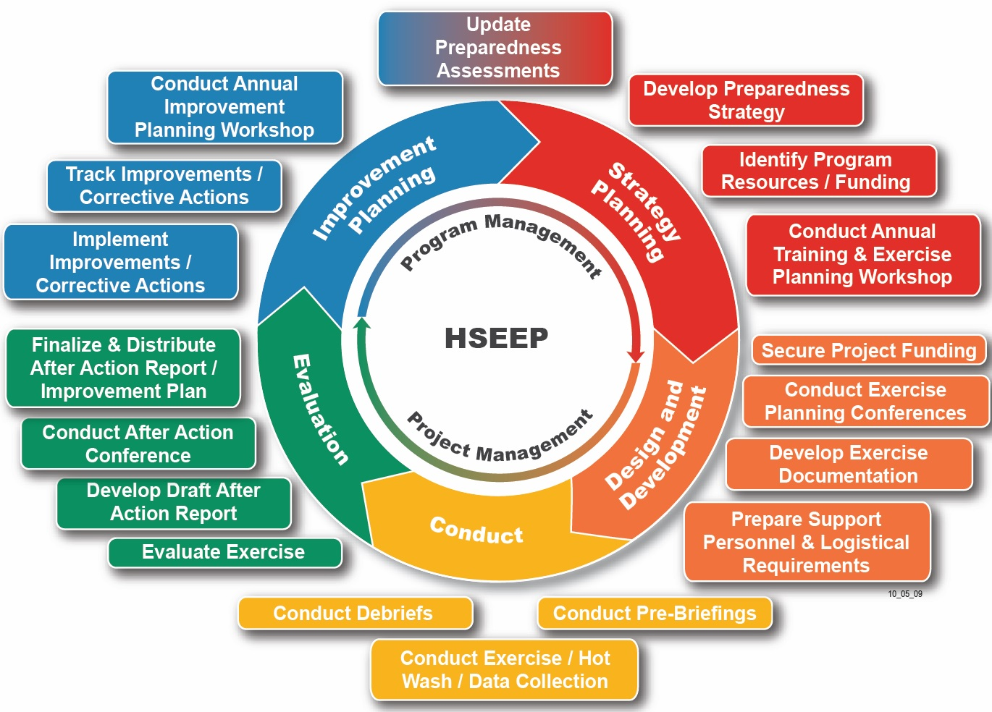

Integrated Preparedness Planning Team
NAME
Job Title
Department/Unit Name
NAME
Job Title
Department/Unit Name
NAME
Job Title
Department/Unit Name
NAME
Job Title
Department/Unit Name
NAME
Job Title
Department/Unit Name
NAME
Job Title
Department/Unit Name
NAME
Job Title
Department/Unit Name

Purpose
The SafetyU Integrated Preparedness Plan (IPP) contains preparedness priorities, outlining steps designed to build and sustain capabilities while tailoring them to the company’s unique needs. The plan provides SafetyU with direction, accountability, and coordination. Safety University Business Continuity Department administers the IPP under delegated authority of the Board of Directors and Chief Executive Officer. All Safety University Departments follow the IPP.
This IPP lays out the company’s threats, hazards, and risks along with other internal and external factors which influence the preparedness priorities for calendar year 202X-202X. The preparedness priorities, corresponding capabilities, and rationale are included in the IPP with multi-year calendars outlining all preparedness activities.
The Safety University IPP is designed to be a living document that will be updated and refined at least annually or as needed to inform the continuous improvement of the company’s ability to build, sustain, and deliver capabilities.

pREPAREDNESS aCTIVITY cONSIDERATIONS
The SafetyU Integrated Preparedness Plan (IPP) is a foundational document to guide successful preparedness activities related to the company’s capabilities for responding to, recovering from, and mitigating the effects of the threats, hazards, and risks deemed the most applicable to the area. The IPP establishes priorities and goals that will guide the company’s efforts to build, improve, and sustain capabilities across a broad range of FEMA mission areas.

Threats, Hazards, and Risks
Safety University utilizes the Hazard Vulnerability Analysis (HVA) process to identify the most likely hazards that may affect the company. These are by no means the only possible incidents that could impact the company. Modifications are made to the HVA based on a continued assessment of risks company wide. A specific threat analysis review occurs at least every two (2) years. Some hazardous events occur on a near annual basis; others may not occur within a lifetime. Additionally, not every hazardous event occurs with notable damage or loss of life. For this reason, hazards are assessed by comparing the experienced frequency of the event versus the potential impact that may result. Planning begins with events that are expected to challenge current company capabilities the most, while also taking into account those that occur often and have potentially high impacts on life and property, followed by those with more moderate probabilities or moderate impacts.
In 202X, the company carried out a Hazard Vulnerability Analysis (HVA) to examine:
- What threats and hazards can affect the company?
- What the impacts of those threats and hazards would be on the company?
- What capabilities should the company have based on those impacts?
- What capabilities are needed?
The threats, hazards, and risks identified in this process for the company as having the greatest impact or challenging capabilities the most are:
- Information Technology Failure
- Active Shooter
- Pandemic/Epidemic Impact
- Cyber Attack/Ransomware
- Fire

Capability Assessments, Corrective Actions, and Improvement Plans
Utilizing the 202X HVA results, the company then performed a capabilities assessment to assess current capabilities against HVA targets. Results from the Integrated Preparedness Plan Workshop (IPPW) identified key gaps for the following FEMA core capabilities:
- Operational Coordination
- Cybersecurity, and
- Physical Protective Measures
Additionally, a gap of capability knowledge was identified for:
- Incident Command System, and
- Cybersecurity.
During the 202X Cyberattack After-Action Report (AAR), it was identified that the following company capabilities related to this event revealed opportunities for improvement:
- Public Information and Warning,
- Critical Transportation,
- Mass Care Services, and
- Operational Communication.
As such, an Improvement Plan from Cyberattack exercise was developed and corrective actions were identified, assigned, and implemented across all elements of the Integrated Preparedness Cycle.

Standards, Guidelines, and Regulations
Safety University aligns resiliency plans and programs with the U.S. National Incident Management System (NIMS), ISO 22301:2019 Security and resilience — Business continuity management systems — Requirements, NFPA 1600 – Standard on Continuity, Emergency, and Crisis Management, applicable State/Local Emergency Operations Plan(s).

Preparedness Priorities
Based on the aforementioned considerations, Safety University IPPW participants determined the following three priorities will be the focus for the multi-year cycle of preparedness for CY 202X-202X:
SAFETY UNIVERISTY CY 202X-202X PREPAREDNESS PRIORITIES
- IT Resiliency – Increase the company’s ability to respond to and mitigate the effects of a technology outage or compromise.
- Incident Management – Improve the company’s ability to systematically manage incidents that require the activation of the company’s Business Continuity Plan while leveraging the National Incident Management System and the Incident Command System (ICS).
- Mass Care Services – Increase the company’s proficiency to respond to and manage pandemic/epidemic impacts.

Priority: IT Resiliency – Increase the company’s ability to respond to and mitigate the effects of a technology outage or compromise.
As SafetyU grows, the demands for IT infrastructure increase as well. Instituting robust equipment and procedural upgrades to meet business needs and regulatory requirements is vital. Additionally, SafetyU is committed to developing cyber response capabilities in coordination with external partners, raising awareness of cybersecurity, and developing appropriate partnerships to better protect critical infrastructure from cyber threats.

Corresponding FEMA Core Capabilities:
- Situational assessment,
- Cybersecurity,
- Forensics and attribution,
- Intelligence and Information Sharing,
- Infrastructure Systems, and
- Company Resilience

Rationale:
During the IPP workshop a gap in capability knowledge was identified for cybersecurity. Additionally, past incidents have revealed vulnerabilities that required resolution.
As the company continuously improves and grows, it has identified the need to increase redundancy and resiliency of the IT systems. Additionally, cyberattack/ransomware incidents have increased over the past years. Protecting the company’s infrastructure and data is top priority.

Planning Factors:
- IT Cybersecurity Strategic Plan
- IT Infrastructure Modernization Roadmap
  - Implementing infrastructure as code to allow automation of buildup and tear down of infrastructure components (e.g. networks, servers, firewalls, and load balancers).
  - Building infrastructure in hybrid-cloud environment to support production workflows.

Organization and Equipment Factors:
- Continue cyber assessment for resource determination; and
- Resiliency of the backup Data Center for active standby

Supporting Training Courses:
- HIPAA Compliance Training
- Job Specific Risk Training
- Data Security Training
- Phishing Alert Training
- FEMA IS 915 Protecting Critical Infrastructure Against Insider Threats

Priority: Incident Management – Improve the company’s ability to systematically manage incidents that require the activation of the company’s Business Continuity Plan while leveraging the National Incident Management System and the Incident Command System (ICS).
As the company grows, adopting the National Incident Management System’s Incident Command System (ICS) will ensure a flexible, standardized approach for all crisis or unplanned events is used. The Incident Command System (ICS) is a standardized approach to the command, management, and coordination of emergency response providing a common hierarchy that will help address the challenges of avoiding duplicative efforts and continuing overhead, providing logistical and administrative support to operational staff, and providing a unified, centrally authorized emergency organization.

Corresponding FEMA Core Capabilities:
- Planning
- Public Information and Warning
- Operational Coordination
- Operational Communication
- Situational Assessment

Rationale:
The company has not widely adopted the Incident Command System (ICS) for incident management during a crisis or unplanned event. Adopting this system will align the company with industry best practices and provide a standardized, flexible program to ensure efficient emergency response.

Planning Factors:
- Emergency Operations Plan
- Business Continuity Plan
- Crisis Communications Plan

Organization and Equipment Factors:
- Establish a pre-assigned Incident Management Team (IMT).

Supporting Training Courses:
- Provide Incident Management Team (IMT) members core Incident Command System training to include ICS 100, ICS 200, and ICS 700, and
- Provide ICS awareness level training to all other workforce members.

Priority: Mass Car Service – Increase the company’s proficiency to respond to and manage the impacts of pandemic/epidemic incidents.
The safety of the company’s workforce is vital the success of its mission and strategies. Providing robust procedures and training on how to detect, respond, and handle emerging infectious diseases increases the safety of the applicable staff and securing a safety physical work environment.

Corresponding FEMA Core Capabilities:
- Mass Care Services
- Threats and Hazards Identification

Rationale:
During the 2019 COVID Response after action review, several action items and opportunities for improvement were noted. These items were developed through a comprehensive interview process whereby nearly all persons that staffed positions in the Incident Management Team (IMT) had an opportunity identify strengths and weaknesses.

Planning Factors:
- Emergency infectious diseases plan

Organization and Equipment Factors:
- None noted

Supporting Training Courses:
- TBD – Need to research current training available

Priority Monitoring
Preparedness priorities will be continuously monitored for effectiveness and appropriateness. If any changes arise what would warrant a change in the preparedness cycle; an Integrated Preparedness Plan Workshop will be held to address said changes and update the priorities accordingly. Any updates or changes during the preparedness cycle does not alter the cycle dates/timeframe.

Program Reporting
By continuously monitoring improvement actions, SafetyU can periodically examine capabilities to ensure they are sufficient, accurate, and effective to handle the threats, hazards, and risks facing the company and can inform future Integrated Preparedness Cycle activities.

Safety University will use the following actions as part of program reporting procedures:
- The Business Continuity Department will compile and record areas for improvement, lessons-learned, and potential best practices identified from exercises and real-world incidents;
- Identify which actions are needed to address areas for improvement using the following questions:
  - What changes need to be made to plans and procedures?
  - What changes need to be made to organizational structures?
  - What changes to equipment or resources are needed?
  - What training can be leveraged to increase knowledge?
- Align actions to capabilities to allow for the measurement of the effect on corresponding capabilities;
- Prioritize and assign SMART corrective actions to one primary stakeholder to the greatest extent possible; and
- All corrective actions will be tracked and reported on in a summary report provided to company’s senior leaders and applicable stakeholders on, at least, an annual basis.

Multi-Year Integrated Preparedness Schedule

202X Calendar Year Schedule
Activity | IT Resiliency | Incident Management | Mass Care Services
Plan | - Q4 Active/Standby Failover Plan  - Q4 Full Environment Backup/Restore Plan | - Emergency Operations Plan and Annexes/Appendices  - Corporate Crisis Communications Plan | Develop comprehensive emergency infectious disease plan
Organize | Establish a Restore Taskforce | Develop pre-assigned Incident Management Team (IMT) | None noted
Equip | Operationalize backup data center with full failover capability | None noted | None noted
Train | Q3-Q4 Backup/Restore Procedures | - ICS Awareness  - ICS 100, 200, 700  - Pilot ICS Course | - TBD
Exercise | - Q2-Q3 – Disaster Recovery Full Scale Exercise  - Q4 Full Environment Backup/Restore (onsite/ backup data center) Test | - Q2-Q3 Tabletop exercise (TTX) – Active Violence w/EOC Committee  - Q4 Building Evacuation Drill | Q3 Tabletop exercise (TTX) w/company leadership

202X Calendar Year Schedule
Activity | IT Resiliency | Incident Management | Mass Care Services
Plan | - Add automation for all manual activities  - Identify procedures to ensure Restore Taskforce is sustained  - Update applicable BIAs based on backup DC’s maturing functionality | Update EOP and BCP in alignment with maturing company functionality | None noted
Organize | Identify additional Restore Taskforce members | Cross training company Incident Management Team members | Develop process for logistical and supply chain management
Equip | Increase backup data center capabilities for parallel production environment to primary data center | Build out Emergency Operations Center (EOC) | None noted
Train | Cross train Restore Taskforce members | - ICS 100, 200, 700  - ICS Awareness | Q1 Refresher Training
Exercise | - Q4 Full Environment Backup/Restore (VPN and primary data center) Test | See IT Resiliency Exercise | Q3 Tabletop exercise (TTX) w/MedSurg & ICU personnel

202X Calendar Year Schedule
Activity | IT Resiliency | Incident Management | Mass Care Services
Plan | Update plans to encompass multiple restore locations (e.g., virtual/cloud) | TBD | None noted
Organize | TBD | None noted | None noted
Equip | TBD | None noted | None noted
Train | TBD | - New IMT Members: ICS 100, 200, 700  - ICS Position specific training  - Use of ICS forms | Q1 Refresher Training
Exercise | Q4 Full Environment Backup/Restore (onsite/ backup data center) Test | Q2 Functional Exercise (FE) – Network Outage | Q3 Tabletop exercise (TTX) w/emergency department personnel

