SITUATION SUMMARY
[INSERT SHORT SUMMARY OF CURRENT SITUATION, PROGRESS, CHALLENGES, ISSUES, ETC.]
SAFETY AND SECURITY
 | COMPONENT | Workforce Member Safety/Security | - No significant updates to report at this time.
 | COMPONENT | Infrastructure Safety/Privacy | - No significant updates to report at this time.
 | COMPONENT | Community Safety | - No significant updates to report at this time.

FOOD, WATER, SHELTER
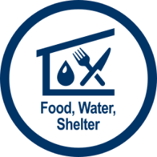 | COMPONENT | Food | - No significant updates to report at this time.
 | COMPONENT | Water | - No significant updates to report at this time.
 | COMPONENT | Shelter | - No significant updates to report at this time.

HEALTH AND MEDICAL
 | COMPONENT | Medical Care/ Injuries/Fatalities | - No significant updates to report at this time.

ENERGY
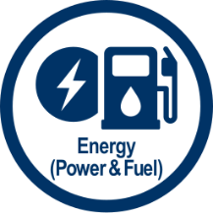 | COMPONENT | Power | - No significant updates to report at this time.
 | COMPONENT | Fuel | - No significant updates to report at this time.

COMMUNICATIONS
 | COMPONENT | Communication/IT Infrastructure | - No significant updates to report at this time.
 | COMPONENT | Alerts, Warnings, and Messages | - All reporters and media requests should be sent to 24/7 media line XXX-XXX-XXXX.

TRANSPORTATION
 | COMPONENT | Highway/Roadway | - No significant updates to report at this time.
 | COMPONENT | Supply Chain Transport | - No significant updates to report at this time.

HAZARDOUS MATERIALS
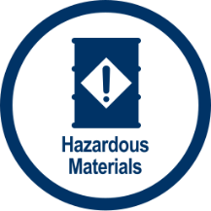 | COMPONENT | Facilities | - No significant updates to report at this time.
 | COMPONENT | Pollutants | - No significant updates to report at this time.
 | COMPONENT | Contaminants | - No significant updates to report at this time.
 | COMPONENT | Releases/Spills | - No significant updates to report at this time.

